Simple Machines Test
Science
Kleinburg Public School
Part One : Definitions
Write the definition for each term: ( 8 MARKS)

Work:__________________________________________________________________________________________________________________________________________
Energy:_________________________________________________________________________________________________________________________________________
Load:__________________________________________________________________________________________________________________________________________
Effort:__________________________________________________________________________________________________________________________________________

Part Two : True or false ( 8 MARKS)

T / F 1) Simple machines are tools that make work easier.
T / F 2) Simple machines have many complex parts.
T / F 3) Simple machines require no energy to do work.
T / F 4) Simple machines do work with one movement.
T / F 5) Simple machines give us an advantage by changing the amount, speed or direction of forces.
T / F 6) Simple machines require a much greater force to overcome a smaller force.
T / F 7) The amount of effort saved when using a simple machine is called the simplification equilibrification equation.
T / F 8) MA means mechanical advantage.

Part Three: What is a simple Machine? ( 6 MARKS)
Name the two groups of simple machines and provide three examples of each:

Group 1 ______________
*_____________________
*_____________________
*_____________________
Group 2_______________
*_____________________
*_____________________
*_____________________

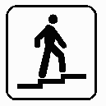

1.)Ramp ( 6 MARKS)
A ramp (inclined plane) helps us to move heavy objects more easily. We use less force. Friction is one problem encountered in using a ramp to move heavy objects.
List two trade-offs for using a ramp or inclined plane:
________________________________________________________________________________________________________________________________________________________________________________________________________________________________________________________________________________________________
Provide four examples of ramps or inclined planes.
__________________________________
__________________________________
__________________________________
__________________________________

2.)Wedge ( 5 MARKS)
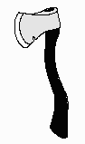
A wedge consists of two back-to-back inclined planes. A wedge looks like an inclined plane but it works differently. It can either hold things together, as in a doorstop or nail, or it can split things apart, as in an axe or chisel.

List one trade-off for using a wedge
________________________________________________________________________________________________________________________________________________________________________________________________________________________________________________________________________________________________
Provide four examples of a wedge ( not those listed above)
__________________________________
__________________________________
__________________________________
__________________________________

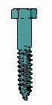
3.) Screw ( 6 MARKS)
A screw is an inclined plane wound about a nail. The ridges are called the thread of a screw. These threads cut a groove in the wood as you turn the screw, making it hold very tightly. To remove a screw you have to turn in the opposite direction with a screwdriver. It is very difficult to remove a screw by pulling it straight out. As with any inclined plane used as a simple machine, the force required is less but the distance travelled is greater.
List two trade-offs for using a screw
________________________________________________________________________________________________________________________________________________________________________________________________________________________________________________________________________________________________
Provide four examples of a screw ( not those listed above)
__________________________________
__________________________________
__________________________________
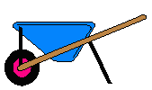
__________________________________
4.) Lever ( 9 MARKS)
The lever is a bar that turns on a point called a fulcrum.
The secret of the lever is the increased distance over which the force moves, i.e., the arm length of the lever, which is determined by the position of the fulcrum (pivot). It is the same principle as the inclined plane - the greater the distance over which the force must be applied, the smaller the force required to do the work (lift the load).
Complete the chart for each class of lever, by indicating the location of the fulcrum, one example of each class of lever, and one trade-off. ( make diagrams if necessary)
Class of Lever | Location of Fulcrum | Example of lever | Trade _off
1rst class
2nd class
3rd class
5)A wheel and axle ( 5 MARKS)
A wheel and axle is a lever that is able to rotate through a complete circle (360 degrees ). The circle turned by the wheel is much larger than the circle turned by the axle. The increased distance over which the force is applied as the wheel turns results in a more powerful force on the axle, which moves a shorter distance.
List a trade-off for using a wheel and axle
________________________________________________________________________________________________________________________________________________________________________________________________________________________________________________________________________________________________
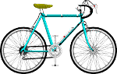
Provide four examples of a wheel and axle.
__________________________________
__________________________________
__________________________________
__________________________________

6.Pulleys ( 8 MARKS)
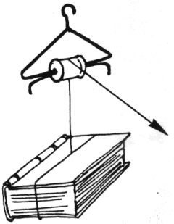
Pulleys are wheels with grooves around the rim. The pulley turns as a string moves over the wheel and a load is raised as the string is pulled.

Complete the chart for each type of pulley by indicating the trade-off

Type of Pulley | Characteristics | Trade-off
Single pulley | *reverses the direction of the force
Combination pulley | *reverses the direction of the force  * two or more pulleys connected together
Fixed Pulley | *may be single or combination  *makes work easier by changing direction of applied force
Moveable Pulley | *may be single or combination  * a pulley that moves with the load

Provide four examples of pulleys.
__________________________________
__________________________________
__________________________________
__________________________________

Just for fun and bonus marks
1.)Find the names of following simple machines hidden amongst the letters below:
seesaw, ramp, wedge, lever, axle, wheel, screw, gear, pulley
Draw a line around each word as you find it. ( 2 bonus marks, but you have to find them all)
a | s | e | e | s | a | w | u | k | l
f | l | r | o | r | z | h | f | n | e
k | r | w | a | x | l | e | o | b | v
e | p | s | u | d | m | e | i | l | e
p | u | l | l | e | y | l | s | h | r
s | l | o | r | k | a | s | u | r | s
l | c | s | c | r | e | w | l | a | c
n | g | k | m | c | m | j | x | m | y
w | h | g | e | a | r | a | r | p | i
q | s | l | m | p | w | e | d | g | e

2. Circle the fulcrum of the (lever) that you think would balance. ( 1 bonus mark)
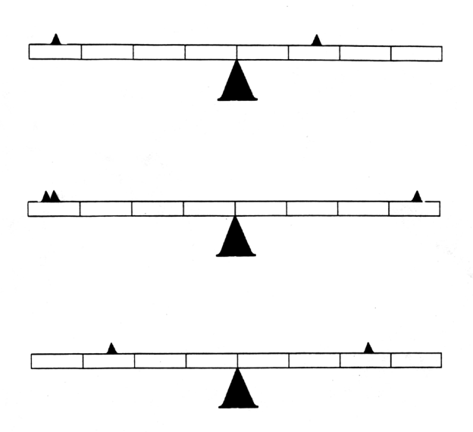

3. From the wordbox below, choose the correct words to complete the following sentences. Write your answers on the lines provided. ( 1 BONUS MARK)
lever  circle  cotton  inclined plane | seesaw  screw  car  swing | pulley  axle  wheel  gear | square  radio  ramp  scissors
Ant is to insect as seesaw is to ______________ .
Tread is to tire as thread is to ______________.
Carrot is to vegetable as screw is to ______________.
Circle is to ring as slope is to ______________.
Knife is to fork as wheel is to _______________.

Test mark _______
Bonus _______
Total _______ ______
61

Test based on review materials located on web-site listed below
The test can be quickly marked using the review material.

http://www.camillasenior.homestead.com/Review_Simple_Machines.pdf

